Grammar- Forms of Verb (Tense)

Verb Forms V1 V2 V3 V4 V5 | 250+ Verbs
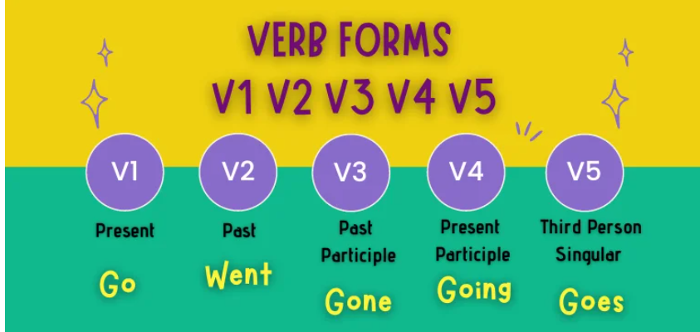

On this page, you will find 250+ Verbs with Verb Forms V1 V2 V3 V4 V5.

Verb Forms V1 V2 V3 V4 V5
The five verb forms are –
- V1 – Present Form of Verb
- V2 – Past Form of Verb
- V3 – Past Participle Form of Verb
- V4 – Present Participle Form of Verb
- V5 – Third Person Singular Present Form

Verb Form V1
Verb form V1, known as the Present form of Verb, is the verb’s root form or base form. That means they are in their original form without any changes or modifications.
Examples of verb form v1 (Present Tense form of Verb) –
- I work in a garment factory. (Verb form V1 – work)
- They do not treat us well. (Verb form V1 – treat)
- This truck can carry approx. 1000 kilo weight. (Verb form V1 – carry)

Verb Form V2
Verb form V2, the Past form of Verb, refers to an action/event that happened in the past. Usually, the past form of a verb is formed by adding “–ed” to the end of the root verb.
For example –
Work (V1) – worked (V2)
Treat (V1) – treated (V2)
Note: – If a root verb ends with the letter “e,” we only add “-d.”
For example –
Like (V1) – liked (V2)
Close (V1) – closed (V2)
However, some verbs do not follow this rule. Sometimes they completely change from their base form, and sometimes they do not change at all. They are known as irregular verbs.
For instance, verbs like cut, put, and hurt remain the same in V1, V2, and V3 verb forms.

Cut (V1) – Cut (V2) – Cut (V3)
Put (V1) – Put (V2) – Put (V3)
Hurt (V1) – Hurt (V2) – Hurt (V3)
On the other hand, verbs such as “go” change completely;
Go (V1) – went (V2)

Verb Form V3
Verb form V3, known as the Past Participle form of Verb, refers to the present, past, or future perfect tense.
The Verb form V2 (Past form of Verb) and the Verb form V3 (Past participle form of Verb) remain the same for regular verbs.
For example-
Work (V1) – worked (V2) – worked (V3)
However, if a verb is irregular, it is possible that the spelling might change when it is in its past participle form.
For example –
Go (V1) – went (V2) – gone (V3)

Verb Form V4
Verb form V4, the Present Participle form of Verb, is formed by adding “–ing” to the root verb. Thus, this form is also known as the ing form of the verb. The present participle form of the verb is used in the past, present, and future continuous tenses.

For example –
Go (V1) – going (V4)
Work (V1) – working (V4)

Verb Form V5
Verb form V5, the Third Person Singular Present form of Verb, is used in the simple present tense. It is formed by adding “s” or “es” to the end of the root verb.
For example –
Go (V1) – goes (V5)
Work (V1) – works (V5)

List of 250+ Verbs with Verb Forms V1 V2 V3 V4 V5
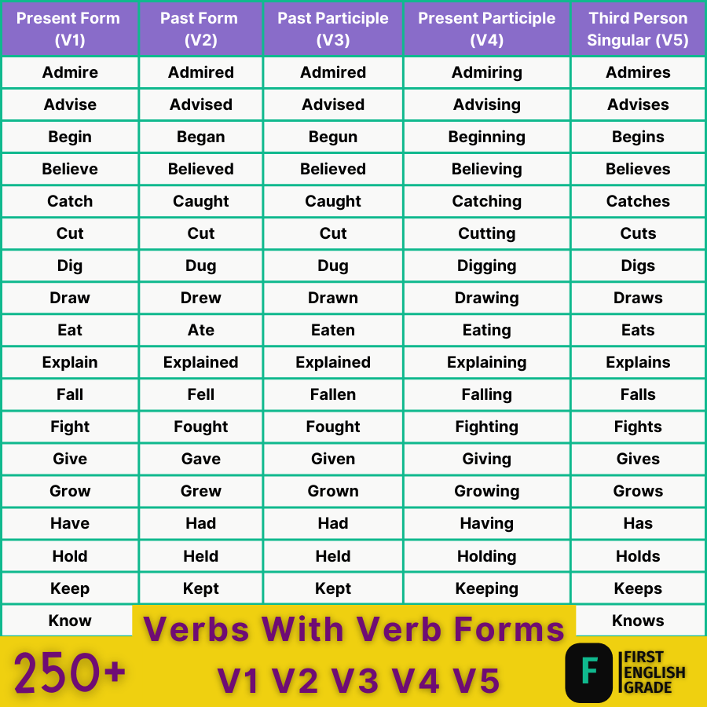
Here is the list of 250+ verbs with their verb forms V1 V2 V3 V4 V5…
Present Form (V1) | Past Form (V2) | Past Participle (V3) | Present Participle (V4) | Third Person Singular (V5)
Abuse | Abused | Abused | Abusing | Abuses
Act | Acted | Acted | Acting | Acts
Add | Added | Added | Adding | Adds
Admire | Admired | Admired | Admiring | Admires
Advise | Advised | Advised | Advising | Advises
Allow | Allowed | Allowed | allowing | Allows
Answer | Answered | Answered | Answering | Answers
Appear | Appeared | Appeared | Appearing | Appears
Appoint | Appointed | Appointed | Appointing | Appoints
Arise | Arose | Arisen | Arising | Arises
Arrest | Arrested | Arrested | Arresting | Arrests
Arrive | Arrived | Arrived | Arriving | Arrives
Ask | Asked | Asked | Asking | Asks
Attack | Attacked | Attacked | Attacking | Attacks
Awake | Awoke | Awoke | Awaking | Awakes
Bake | Baked | Baked | Baking | Bakes
Bark | Barked | Barked | Barking | Barks
Be | Was/Were | Been | Being | Is/Are/Am
Bathe | Bathed | Bathed | Bathing | Bathes
Bear | Bore | Born | Bearing | Bears
Become | Became | Become | Becoming | Becomes
Beg | Begged | Begged | Begging | Begs
Begin | Began | Begun | Beginning | Begins
Behave | Behaved | Behaved | Behaving | Behaves
Behold | Beheld | Beheld | Beholding | Beholds
Believe | Believed | Believed | Believing | Believes
Bend | Bent | Bent | Bending | Bends
Bet | Bet | Bet | Betting | Bets
Bid | Bade | Bidden | Bidding | Bids
Bind | Bound | Bound | Binding | Binds
Bite | Bit | Bitten | Biting | Bites
Bleed | Bled | Bled | Bleeding | Bleeds
Bless | Blessed | Blessed | Blessing | Blesses
Blow | Blew | Blown | Blowing | Blows
Boast | Boasted | Boasted | Boasting | Boasts
Boil | Boiled | Boiled | Boiling | Boils
Borrow | Borrowed | Borrowed | Borrowing | Borrows
Break | Broke | Broken | Breaking | It Breaks
Bring | Brought | Brought | Bringing | Brings
Build | Built | Built | Building | Builds
Burn | Burnt | Burnt | Burning | Burns
Burst | Burst | Burst | Bursting | Bursts
Buy | Bought | Bought | Buying | Buys
Call | Called | Called | Calling | Calls
Carry | Carried | Carried | Carrying | Carries
Cast | Cast | Cast | Casting | Casts
Catch | Caught | Caught | Catching | Catches
Change | Changed | Changed | Changing | Changes
Check | Checked | Checked | Checking | Checks
Choose | Chose | Chosen | Choosing | Chooses
Clap | Clapped | Clapped | Clapping | Claps
Clean | Cleaned | Cleaned | Cleaning | Cleans
Climb | Climbed | Climbed | Climbing | Climbs
Cling | Clung | Clung | Clinging | Clings
Close | Closed | Closed | Closing | Closes
Collect | Collected | Collected | Collecting | Collects
Come | Came | Come | Coming | Comes
Complain | Complained | Complained | Complaining | Complains
Consult | Consulted | Consulted | Consulting | Consults
Cook | Cooked | Cooked | Cooking | Cooks
Copy | Copied | Copied | Copying | Copies
Cost | Cost | Cost | Costing | Costs
Count | Counted | Counted | Counting | Counts
Cover | Covered | Covered | Covering | Covers
Creep | Crept | Crept | Creeping | Creeps
Cross | Crossed | Crossed | Crossing | Crosses
Cry | Cried | Cried | Crying | Cries
Cut | Cut | Cut | Cutting | Cuts

List of 250+ Verbs with Verb Forms V1 V2 V3 V4 V5
Present Form (V1) | Past Form (V2) | Past Participle (V3) | Present Participle (V4) | Third Person Singular (V5)
Dance | Danced | Danced | Dancing | Dances
Deceive | Deceived | Deceived | Deceiving | Deceives
Decide | Decided | Decided | Deciding | Decides
Decorate | Decorated | Decorated | Decorating | Decorates
Defeat | Defeated | Defeated | Defeating | Defeats
Desire | Desired | Desired | Desiring | Desires
Die | Died | Died | Dying | Dies
Dig | Dug | Dug | Digging | Digs
Dip | Dipped | Dipped | Dipping | Dips
Discover | Discovered | Discovered | Discovering | Discovers
Divide | Divided | Divided | Dividing | Divides
Do | Did | Done | Doing | Does
Draw | Drew | Drawn | Drawing | Draws
Dream | Dreamed | Dreamed | Dreaming | Dreams
Drink | Drank | Drunk | Drinking | Drinks
Drive | Drove | Driven | Driving | Drives
Dye | Dyed | Dyed | Dyeing | Dyes
Earn | Earned | Earned | Earning | Earns
Eat | Ate | Eaten | Eating | Eats
Employ | Employed | Employed | Employing | Employs
Enter | Entered | Entered | Entering | Enters
Explain | Explained | Explained | Explaining | Explains
Face | Faced | Faced | Facing | Faces
Fail | Failed | Failed | Failing | Fails
Fall | Fell | Fallen | Falling | Falls
Fear | Feared | Feared | Fearing | Fears
Feed | Fed | Fed | Feeding | Feeds
Feel | Felt | Felt | Feeling | Feels
Fight | Fought | Fought | Fighting | Fights
Find | Found | Found | Finding | Finds
Fine | Fined | Fined | Fining | Fines
Finish | Finished | Finished | Finishing | Finishes
Flee | Fled | Fled | Fleeing | Flees
Float | Floated | Floated | Floating | Floats
Fly | Flew | Flown | Flying | Flies
Forbid | Forbade | Forbidden | Forbidding | Forbids
Forget | Forgot | Forgotten | Forgetting | Forgets
Freeze | Froze | Frozen | Freezing | Freezes
Gather | Gathered | Gathered | Gathering | Gathers
Get | Got | Got | Getting | Gets
Give | Gave | Given | Giving | Gives
Graze | Grazed | Grazed | Grazing | Grazes
Grind | Ground | Ground | Grinding | Grinds
Grow | Grew | Grown | Growing | Grows
Hang | Hung | Hung | Hanging | Hangs
Hate | Hated | Hated | Hating | Hates
Have | Had | Had | Having | Has
Hear | Heard | Heard | Hearing | Hears
Help | Helped | Helped | Helping | Helps
Hide | Hid | Hidden | Hiding | Hides
Hold | Held | Held | Holding | Holds
Hurt | Hurt | Hurt | Hurting | Hurts
Improve | Improved | Improved | Improving | Improves
Invite | Invited | Invited | Inviting | Invites
Join | Joined | Joined | Joining | Joins
Jump | Jumped | Jumped | Jumping | Jumps
Keep | Kept | Kept | Keeping | Keeps
Kill | Killed | Killed | Killing | Kills
Kneel | Knelt | Knelt | Kneeling | Kneels
Knit | Knitted | Knitted | Knitting | Knits
Know | Knew | Known | Knowing | Knows

List of 250+ Verbs with Verb Forms V1 V2 V3 V4 V5
Present Form (V1) | Past Form (V2) | Past Participle (V3) | Present Participle (V4) | Third Person Singular (V5)
Laugh | Laughed | Laughed | Laughing | Laughs
Lay | Laid | Laid | Laying | Lays
Learn | Learned | Learned | Learning | Learns
Leave | Left | Left | Leaving | Leaves
Lend | Lent | Lent | Lending | Lends
Let | Let | Let | Letting | Lets
Lie | Lay | Lain | Lying | Lies
Light | Lighted | Lit | Lighting | Lights
Like | Liked | Liked | Liking | Likes
Listen | Listened | Listened | Listening | Listens
Live | Lived | Lived | Living | Lives
Look | Looked | Looked | Looking | Looks
Lose | Lost | Lost | Listening | Loses
Love | Loved | Loved | Loving | Loves
Make | Made | Made | Making | Makes
Marry | Married | Married | Marrying | Marries
Mean | Meant | Meant | Meaning | Means
Meet | Met | Met | Meeting | Meets
Melt | Melted | Melted | Melting | Melts
Mend | Mended | Mended | Mending | Mends
Mix | Mixed | Mixed | Mixing | Mixes
Move | Moved | Moved | Moving | Moves
Name | Named | Named | Naming | Names
Need | Needed | Needed | Needing | Needs
Nip | Nipped | Nipped | Nipping | Nips
Obey | Obeyed | Obeyed | Obeying | Obeys
Open | Opened | Opened | Opening | Opens
Oppose | Opposed | Opposed | Opposing | Opposes
Order | Ordered | Ordered | Ordering | Orders
Pay | Paid | Paid | Paying | Pays
Peep | Peeped | Peeped | Peeping | Peeps
Plant | Planted | Planted | Planting | Plants
Play | Played | Played | Playing | Plays
Plow | Plowed | Plowed | Plowing | Plows
Pluck | Plucked | Plucked | Plucking | Plucks
Praise | Praised | Praised | Praising | Praises
Pray | Prayed | Prayed | Praying | Prays
Preach | Preached | Preached | Preaching | Preaches
Prepare | Prepared | Prepared | Preparing | Prepares
Prevent | Prevented | Prevented | Preventing | Prevents
Promise | Promised | Promised | Promising | Promises
Prove | Proved | Proved | Proving | Proves
Pull | Pulled | Pulled | Pulling | Pulls
Punish | Punished | Punished | Punishing | Punishes
Push | Pushed | Pushed | Pushing | Pushes
Put | Put | Put | Putting | Puts
Quit | Quit | Quit | Quitting | Quits
Quarrel | Quarreled | Quarreled | Quarreling | Quarrels
Rain | Rained | Rained | Raining | Rains
Reach | Reached | Reached | Reaching | Reaches
Read | Read | Read | Reading | Reads
Refuse | Refused | Refused | Refused | Refuses
Remember | Remembered | Remembered | Remembering | Remembers
Repair | Repaired | Repaired | Repairing | Repairs
Reply | Replied | Replied | Replying | Replies
Resign | Resigned | Resigned | Resigning | Resigns
Rest | Rested | Rested | Resting | Rests
Return | Returned | Returned | Returning | Returns
Ride | Rode | Ridden | Riding | Rides
Ring | Rang | Rung | Ringing | Rings
Rise | Rose | Risen | Rising | Rises
Roar | Roared | Roared | Roaring | Roars

List of 250+ Verbs with Verb Forms V1 V2 V3 V4 V5
Present Form (V1) | Past Form (V2) | Past Participle (V3) | Present Participle (V4) | Third Person Singular (V5)
Save | Saved | Saved | Saving | Saves
Saw | Sawed | Sawed | Sawing | Saws
Say | Said | Said | Saying | Says
See | Saw | Seen | Seeing | Sees
Seek | Sought | Sought | Seeking | Seeks
Select | Selected | Selected | Selecting | Selects
Sell | Sold | Sold | Selling | Sells
Send | Sent | Sent | Sending | Sends
Set | Set | Set | Setting | Sets
Shake | Shook | Shaken | Shaking | Shakes
Shed | Shed | Shed | Shedding | Sheds
Shine | Shone | Shone | Shining | Shines
Shoot | Shot | Shot | Shooting | Shoots
Shrink | Shrank | Shrunk | Shrinking | Shrinks
Shut | Shut | Shut | Shutting | Shuts
Sing | Sang | Sung | Singing | Sings
Sink | Sank | Sunk | Sinking | Sinks
Sit | Sat | Sat | Sitting | Sits
Slay | Slew | Slain | Slaying | Slays
Sleep | Slept | Slept | Sleeping | Sleeps
Slip | Slipped | Slipped | Slipping | Slips
Speak | Spoke | Spoken | Speaking | Speaks
Spend | Spent | Spent | Spending | Spends
Spit | Spat | Spat | Spitting | Spits
Spread | Spread | Spread | Spreading | Spreads
Stand | Stood | Stood | Standing | Stands
Stay | Stayed | Stayed | Staying | Stays
Steal | Stole | Stolen | Stealing | Steals
Stick | Stuck | Stuck | Sticking | Sticks
Stop | Stopped | Stopped | Stopping | Stops
Strike | Struck | Struck | Striking | Strikes
Study | Studied | Studied | Studying | Studies
Swear | Swore | Sworn | Swearing | Swears
Sweep | Swept | Swept | Sweeping | Sweeps
Swim | Swam | Swum | Swimming | Swims
Swing | Swung | Swung | Swinging | Swings
Take | Took | Taken | Taking | Takes
Talk | Talked | Talked | Talking | Talks
Teach | Taught | Taught | Teaching | Teaches
Tear | Tore | Torn | Tearing | Tears
Tell | Told | Told | Telling | Tells
Think | Thought | Thought | Thinking | Thinks
Thrust | Thrust | Thrust | Thrusting | Thrusts
Tie | Tied | Tied | Tying | Ties
Touch | Touched | Touched | Touching | Touches
Trust | Trusted | Trusted | Trusting | Trusts
Try | Tried | Tried | Trying | Tries
Understand | Understood | Understood | Understanding | Understands
Use | Used | Used | Using | Uses
Wait | Waited | Waited | Waiting | Waits
Walk | Walked | Walked | Walking | Walks
Wander | Wandered | Wandered | Wandering | Wanders
Wash | Washed | Washed | Washing | Washes
Waste | Wasted | Wasted | Wasting | Wastes
Watch | Watched | Watched | Watching | Watches
Wear | Wore | Worn | Wearing | Wears
Weave | wove | Woven | Weaving | Weaves
Wed | Wedded | Wedded | Wedding | Weds
Weep | Wept | Wept | Weeping | Weeps
Win | Won | Won | Winning | Wins
Wind | Wound | Wound | Winding | Winds
Wish | Wished | Wished | Wishing | Wishes
Wonder | Wondered | Wondered | Wondering | Wonders
Work | Worked | Worked | Working | Works
Worship | Worshipped | Worshipped | Worshipping | Worships
Wound | Wounded | Wounded | Wounding | Wounds
Wrap | Wrapped | Wrapped | Wrapping | Wraps
Wring | Wrung | Wrung | Wringing | Wrings
Write | Wrote | Written | Writing | Writes
Yield | Yielded | Yielded | Yielding | Yields

